**0/1 knapsack backtracking**

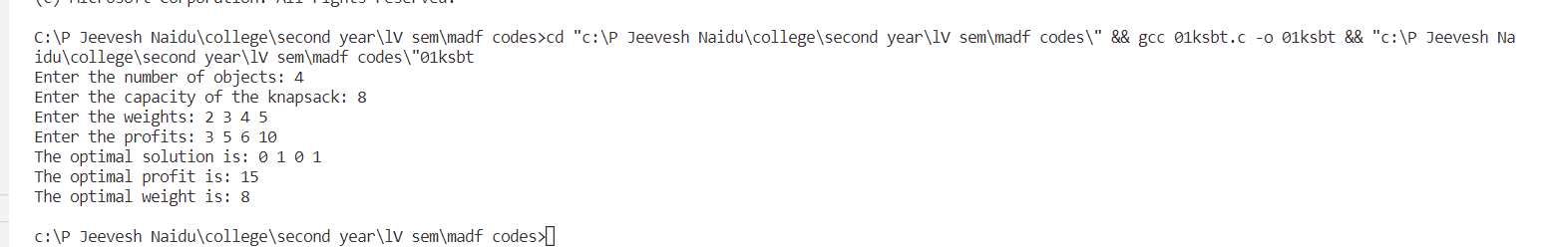

**0/1 knapsack branch and bound**

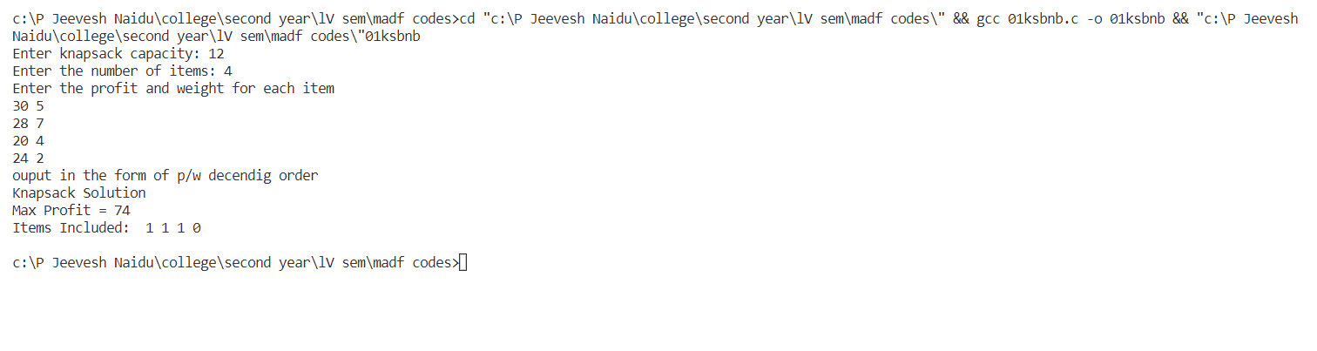

**Kmp**

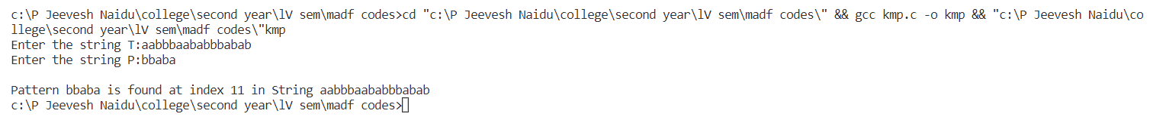

**Bm**

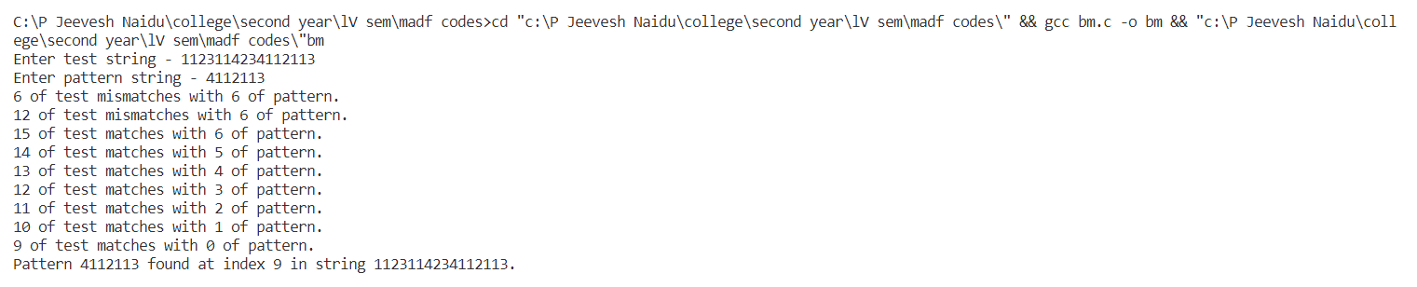

**Huffman**

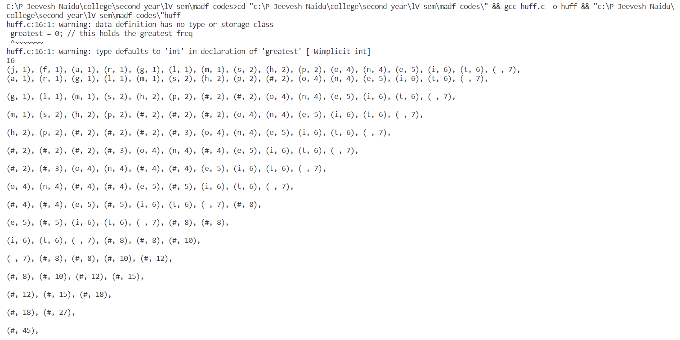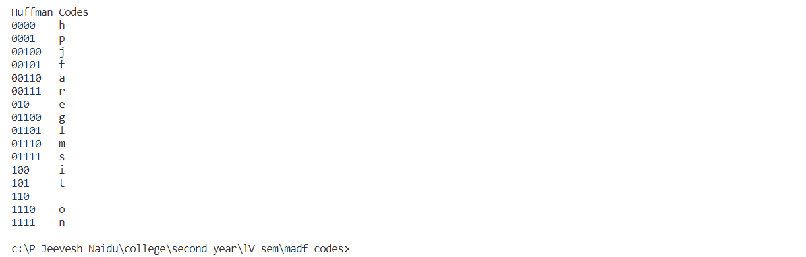

**Lcs**

